

Requirement & Design Specification

**Global Assess Management System (GAMS)**

**Version: 1.0**

– Hanoi, August 2022 –

# Record of Changes

|  |  |  |  |  |
| --- | --- | --- | --- | --- |
| Version | Date | A* M, D | In charge | Change Description |
| V1.0 | 15/2 | A | KienNTHE11 |  |
|  |  |  |  |  |
|  |  |  |  |  |
|  |  |  |  |  |
|  |  |  |  |  |
|  |  |  |  |  |
|  |  |  |  |  |
|  |  |  |  |  |
|  |  |  |  |  |
|  |  |  |  |  |
|  |  |  |  |  |
|  |  |  |  |  |

*A - Added M - Modified D - Deleted

Contents

Record of Changes 2

I. Overview 4

1. System Context 4

2. User Requirements 4

2.1 Actors 4

2.2 Diagrams 5

2.3 Descriptions 6

2.4 Main Workflows 6

3. System Functionalities 7

3.1 Screens Flow 7

3.2 Screen Authorization 8

3.3 Non-UI Functions 8

II. Functional Requirements 9

1. <<Feature Name1>> 9

1.1 <<Screen/Function Name1>> 9

1.2 User Login 9

1.3 … 9

2. System Administration 9

2.1 System Settings 9

2.2 … 10

3. … 10

III. System Design 11

1. Database Design 11

1.1 Database Schema 11

1.2 Table Descriptions 11

2. Code Packages 11

2.1 Package Diagram 12

2.2 Package Descriptions 12

# I. Overview

## 1. System Context

*[Gives the overall description about the product with some introduction and the context diagram. The context diagram presents the boundary and connections between the system you’re developing and everything else in the universe. This identifies external entities (or terminators – software, hardware, human components, and other systems) outside the system that interface to it in some way, as well as data, control, and material flows between the terminators and the system.]*

<<Sample: The Cafeteria Ordering System is a new software system that replaces the current manual and telephone processes for ordering and picking up meals in the Process Impact cafeteria. The context diagram below illustrates the external entities and system interfaces for release 1.0. The system is expected to evolve over several releases, ultimately connecting to the Internet ordering services for several local restaurants and to credit and debit card authorization services.

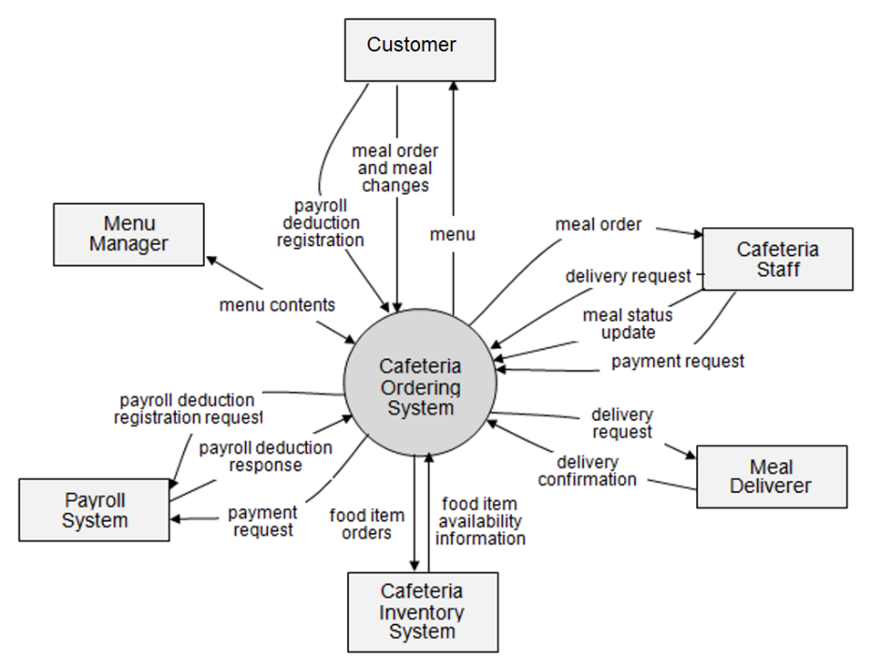

>>

## 2. User Requirements

### 2.1 Actors

*[An actor is someone/something that interacts with the system.*

* *The only external entities that interact with the system*
* *﻿Actors are outside the system and not part of it*
* *﻿A user is an individual, whereas an actor represents the role played by all users of the same type*
* *There are other types of actors in addition to or in place of human actors: external systems, I/O devices, or timers*

*Following are some questions you might ask to help user representatives identify actors*

* *Who (or what) is notified when something occurs within the system?*
* *Who (or what) provides information or services to the system?*
* *Who (or what) helps the system respond to and complete a task?*

*This part gives the description of system actors, you can follow the table form as below]*

|  |  |  |
| --- | --- | --- |
| **#** | **Actor** | **Description** |
| 1 | Administrator | Actor description here.. |
| 2 | Menu Manager | .. |
| 3 | … |  |

### 2.2 Diagrams

*[A use case (UC) describes a sequence of interactions between a system and an external actor that results in the actor being able to achieve some outcome of value. The names of use cases are always written in the form of a verb followed by an object. Select strong, descriptive names to make it evident from the name that the use case will deliver something valuable for some user.*

*Following are some questions you might ask to help user representatives identify use cases*

* *What will the actor use the system for?*
* *Will the actor create, store, change, remove, or read data in the system?*
* *Will the actor need to inform the system about external events or changes?*
* *Will the actor need to be informed about certain occurrences in the system?*

*In this section, you need to provide the UC diagram(s) to show the actor-UCs and UC-UC relationships like the sample below. You can have multiple UC diagrams for the system, each diagram is for one actor or one workflow]*

#### 2.2.1 UCs for Guest

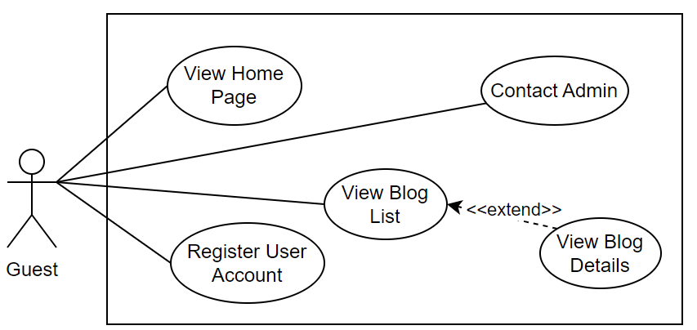

#### 2.2.2 UCs for Student

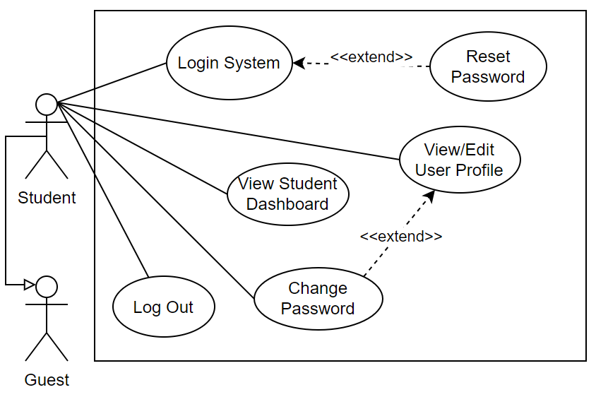

#### 2.2.3 …

### 2.3 Descriptions

*[This part describes the use cases, you can follow the table form as below]*

|  |  |  |  |
| --- | --- | --- | --- |
| **ID** | **Use Case** | **Actors** | **Use Case Description** |
| 01 | View Menu | Patron |  |
| 02 | Order a Meal | Patron |  |
| 03 | … |  |  |

### 2.4 Main Workflows

*[Provide main workflows (business processes) using the swim-lane diagram(s) like sample below]*

#### 1.2.1 Order Processing

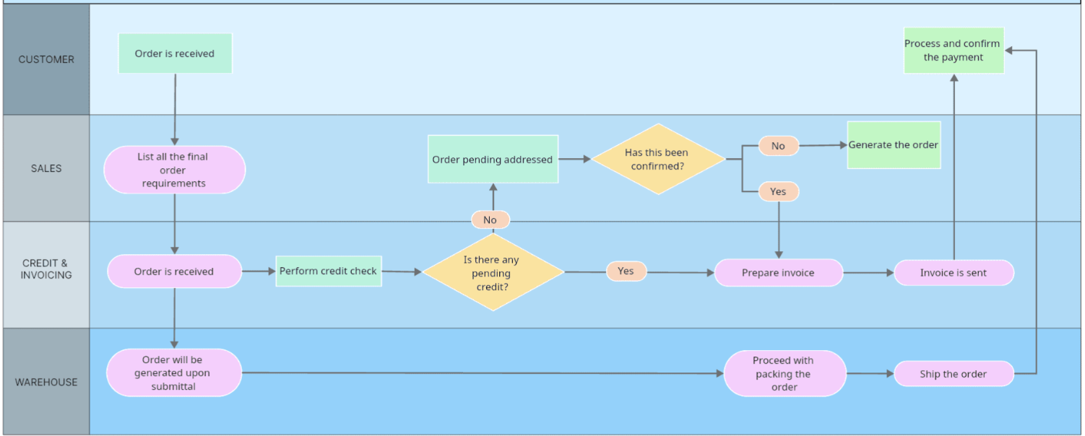

#### 1.2.2 Customer Support

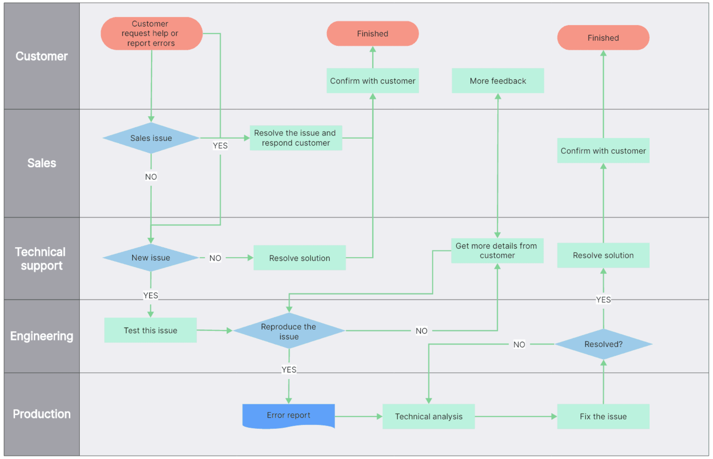

## 3. System Functionalities

*[Provide functionality overview of software system: screen flow, screen descriptions, system user roles, screen authorization, non-screen functions, ERD]*

### 3.1 Screens Flow

*[This part shows the system screens and the relationship among screens. You can draw the Screens Flow for the system in the form of diagram as below.]*

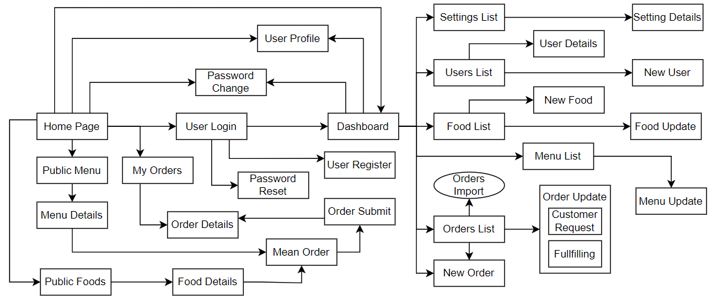

### 3.2 Screen Authorization

*[Provide the system roles authorization to the system features (down to screens, and event to the screen activities if applicable) in the table form as below – replace Role-Name1, Role-Name2,… with your specific system user role names]*

|  |  |  |  |  |
| --- | --- | --- | --- | --- |
| **Screen** | **Role-Name1** | **Role-Name2** | **Role-Name3** | **…** |
| <<Screen Name1>> | X |  | X | X |
| <<Screen Activity>> |  |  | X | X |
| <<Screen Name2>> | X |  | X |  |
| Query All Data | X |  |  |  |
| Query Own Data |  |  | X |  |
| Add New Data |  |  | X | X |
| Update All Data |  |  |  | X |
| Update Own Data |  |  |  | X |
| Delete Data |  |  |  |  |
| … |  |  |  |  |

### 3.3 Non-UI Functions

*[Provide the descriptions for the non-screen system functions, i.e batch/cron job, service, API, etc.]*

|  |  |  |  |
| --- | --- | --- | --- |
| **#** | **Feature** | **System Function** | **Description** |
| 1 | <<Feature Name>> | <<Function Name1>> | <<Function Name1 Description>> |
| 2 | … |  |  |

# II. Functional Requirements

*[Provide descriptions about the system’s functions/screens. The functions/screens are grouped by the system features, and even sub-features if needed. For the screens, you need to provide the screen layouts (mock-up screens) and relevant specifications if needed]*

## 1. <<Feature Name1>>

### 1.1 <<Screen/Function Name1>>

*[Screen/Function description: what are purposes of the screen, how is the screen called, etc.]*

*[Screen layout(s)]*

*[Screen specifications: field initializations, the showing/hiding of some fields, business rules, normal flow, alternative flow, etc.]*

### 1.2 User Login

This screen allows user to be authenticated to the system screens/functionalities.

The main login screen is shown to the user in one of below cases:

* He/she clicks the Login link in the pages’ header
* He/she clicks the Login link in the User Register screen
* He/she is accessing one of the authenticated page while not logging-in yet

|  |  |
| --- | --- |
| ***S1_User Login screen*** | ***S2_Select account to login (with Google)*** |
|  |  |

*[Specifications for the two screens…]*

### 1.3 …

## 2. System Administration

### 2.1 System Settings

#### 2.1.1 Setting List

After clicking the System Configurations link on the NavBar (sider) menu, this page is shown.

This is for the administrator to view the list of current system settings. On this page, s/he can also activate or deactivate (change status) of a specific setting.

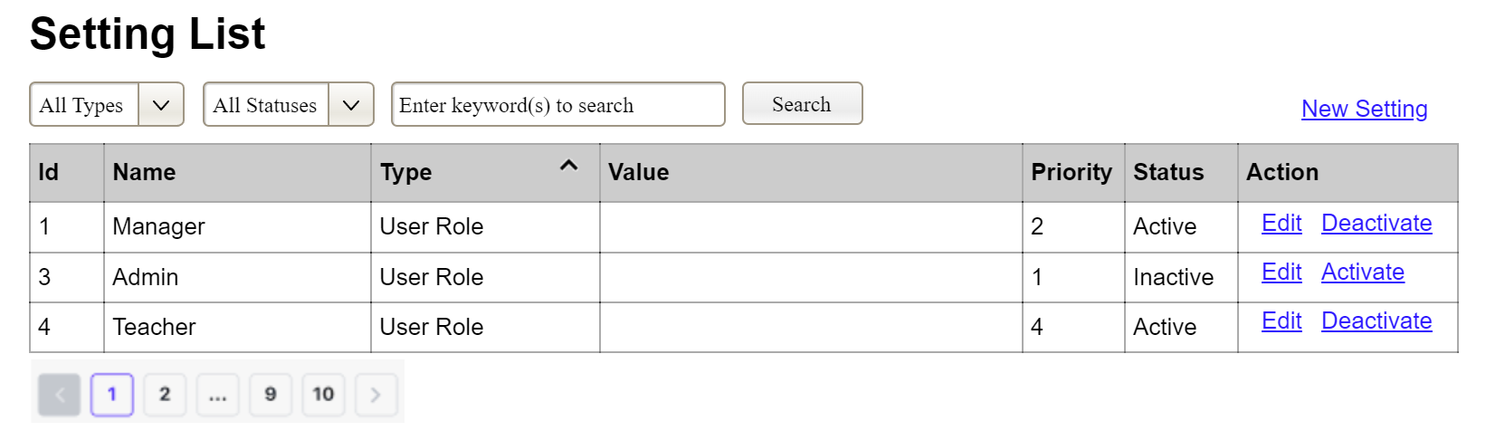

(2)

(3)

(1)

(1) Setting Type:

* Initialized with all the active setting types filled in,
* Allow user to filter the setting list by a specific setting type
* Default value is “All Types”, allowing user to see the settings at all types

(2) Setting Status:

* Initialized with two values Active and Inactive filled in
* Allow user to filter the setting list by a specific status (Active or Inactive)
* Default value is “All Types”, allowing user to see the settings at all statuses

(3) The change-status action is Activate or Deactivate depending on the current status of the relevant setting (Inactive or Active, respectively). The user needs to confirm the status changing via a modal confirmation message before getting that done.

…

#### 2.1.2 Setting Details

This page is shown after the user click the New Setting link or the Edit link in the Setting List page

This is for the administrator to add new or view/update an existing system setting

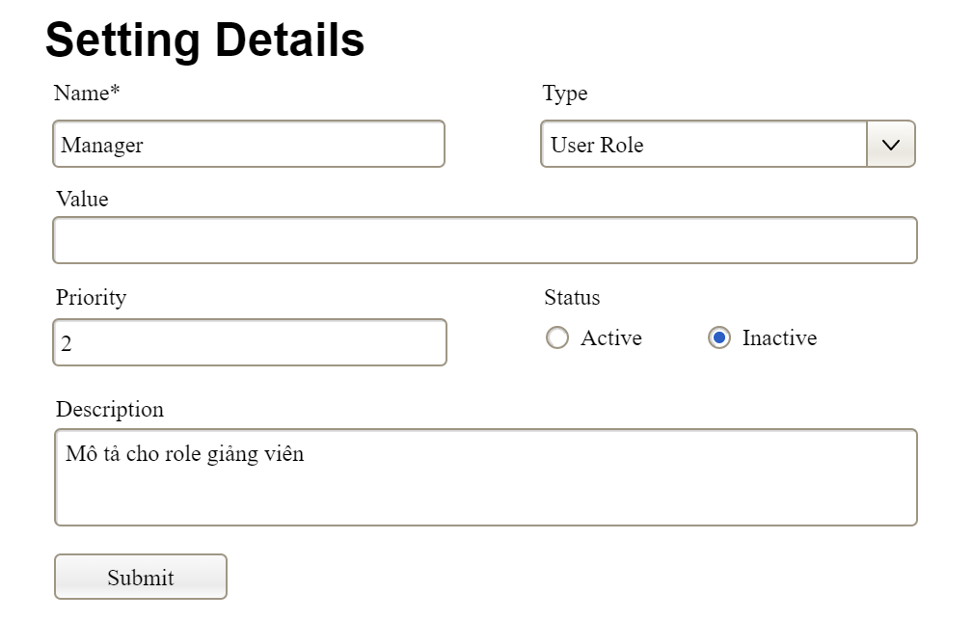

…

### 2.2 …

## 3. …

# III. System Design

## 1. Database Design

*[Provide the tables relationship like example below]*

### 1.1 Database Schema

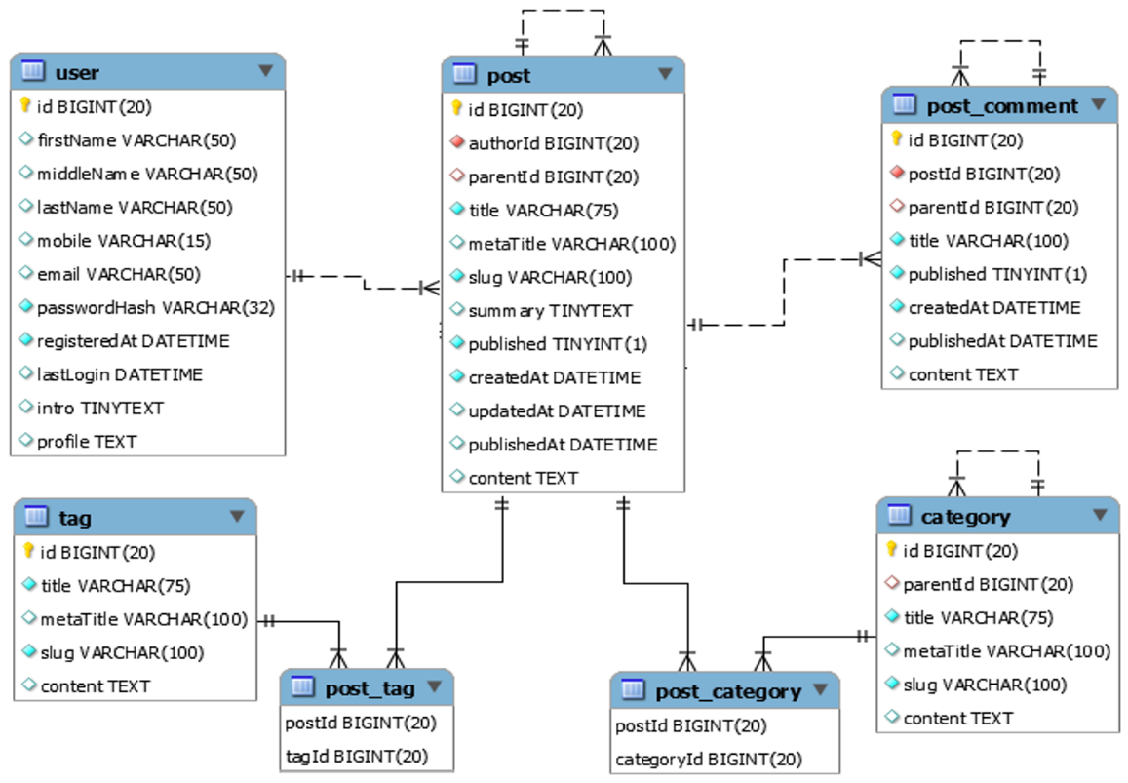

### 1.2 Table Descriptions

|  |  |  |
| --- | --- | --- |
| **No** | **Table** | **Description** |
| *01* | *<Table name>* | *<Description of the table>*  *- Primary keys: <<list of primary key fields>>*  *- Foreign keys: <<list of foreign key fields>>*  *- Unique keys:<<list of unique field or unique field set>>* |
| *02* | *<Table name2>* | *…* |

## 2. Code Packages

*[Provide the package diagram for the system (or sub systems) and package description similar to sample diagram and using description table format below]*

### 2.1 Package Diagram

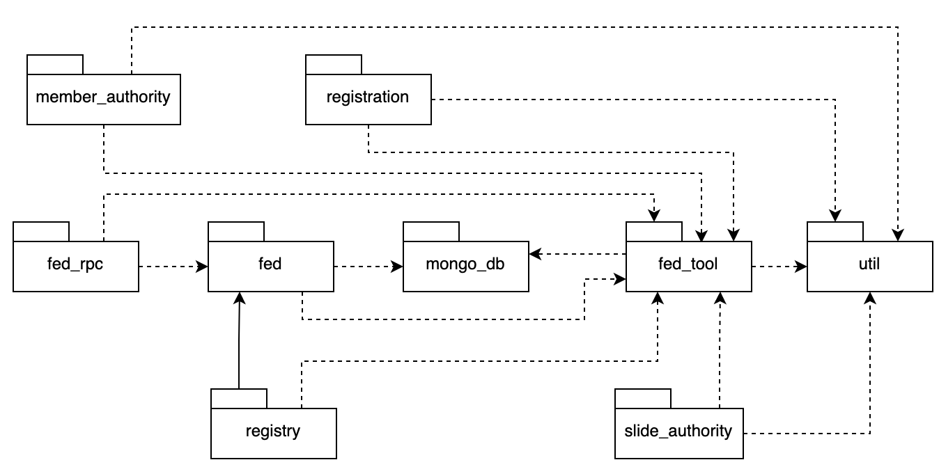

### 2.2 Package Descriptions

|  |  |  |
| --- | --- | --- |
| **No** | **Package** | **Description** |
| *01* | *member_authority* | *<Description of the package: purpose, contents,..>* |
| *02* | *registration* | *<Description of the package: purpose, contents,..>* |
| *03* | *…* |  |